The University of Azad Jammu and Kashmir
Muzaffarabad

Name | Sakeena Bano
Roll no | 2024-SE-29
Course Title | Database System
Lab | 3
Submitted to | Engr. Awais Rathore

Department of Software Engineering

Objective:
The objective of this lab is to understand how the database is created how tables are created inside datbas and how data is inserted into the tables. This is the basic step of creating any kind of database.

Create Database
Firstly a database name university_labs is created using command.
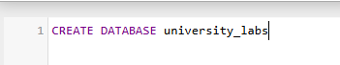
Department Table:
Then the department table is created inside database. Then the data is inserted into the table.
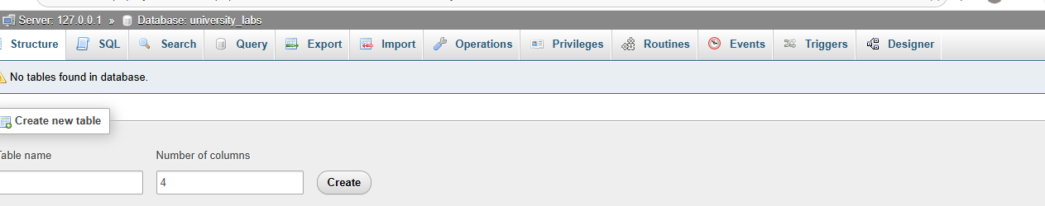

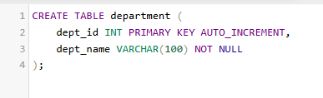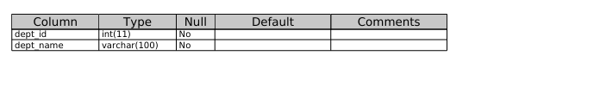
Data:
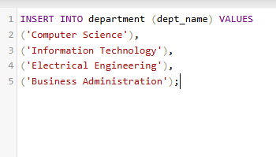
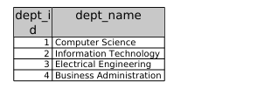

Student table
The student table is created , and data (id , name ,email , and department id )is inserted into it.
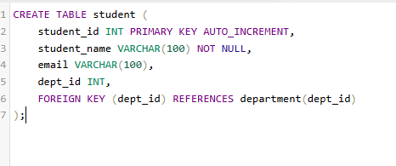
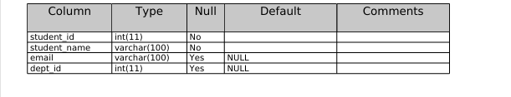

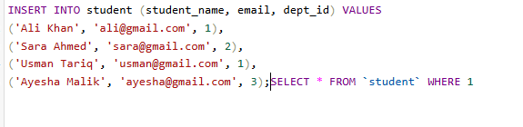
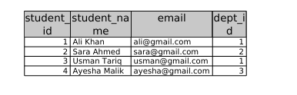
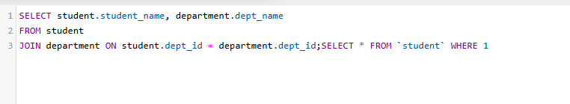

Instructor:
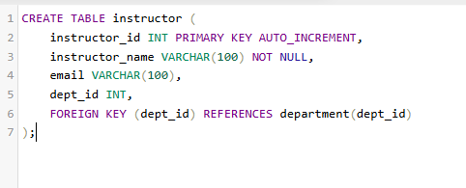
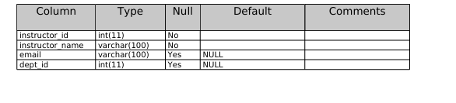
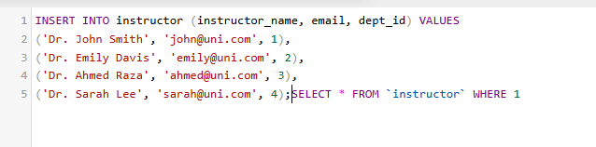
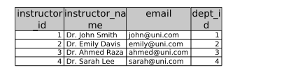

Course Table:

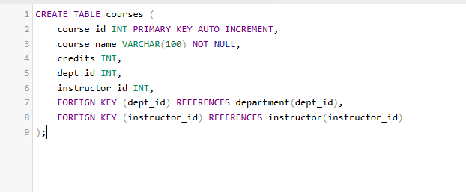
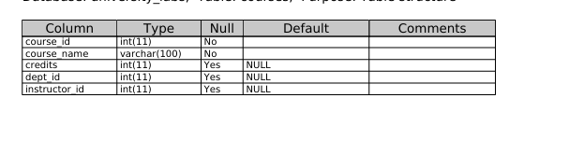
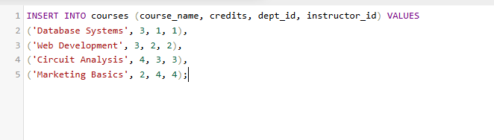
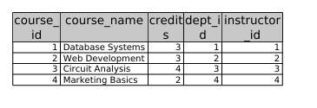

Enrollment:
